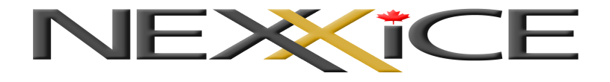
TRYOUT REGISTRATION 2019-2020

Skater First Name: | Skater Last Name:
Birthdate (d/M/Y): | Age as of July 1st, 2019: |  | Gender:  Male Female
Skate Canada Number: | Home Club:
Synchro Experience (Please list all previous teams, current team and number of years):

Competitive skating ( Singles, pairs, ice dance ):

Home Address:

Home Phone: | Cell Phone:
Email Address : (please print clearly)
Parent /Guardian Name(s): | Contact Number:
Parent /Guardian Email Address: (please print clearly)
Have you accepted a position with another team for the 2019 -2020 season? |  |  |  | Yes: |  | No:
Contact Information: nexxiceatbsc@yahoo.ca
Payment Information: |  | Cash |  |  | Cheque

